**ABSTRACT**

GoBikes! is a web application where users make use of it to purchase a product (i.e. bike) through online itself instead of going to showrooms which are especially far from the location of his/her stay. A unique identification is issued for every user who registers into the application and stores their details in the database automatically. The interface is very user-friendly and also makes data processing very fast. The users can also search available products online through “shop by category” making them much easier to purchase. Admin is responsible for adding products into the application making them available for users to purchase.

# HARDWARE REQUIREMENTS:

# Processor - Pentium IV

Speed - 2.4 GHz

RAM - 2GB (min)

Hard Disk - 20 GB

# SOFTWARE REQUIREMENTS:

Operating System - Windows XP/7/10

Browser - Mozilla Firefox, Chrome

Front End - HTML, CSS, BOOTSTRAP, SPRING

Back end - H2 database

GoBikes!

Home page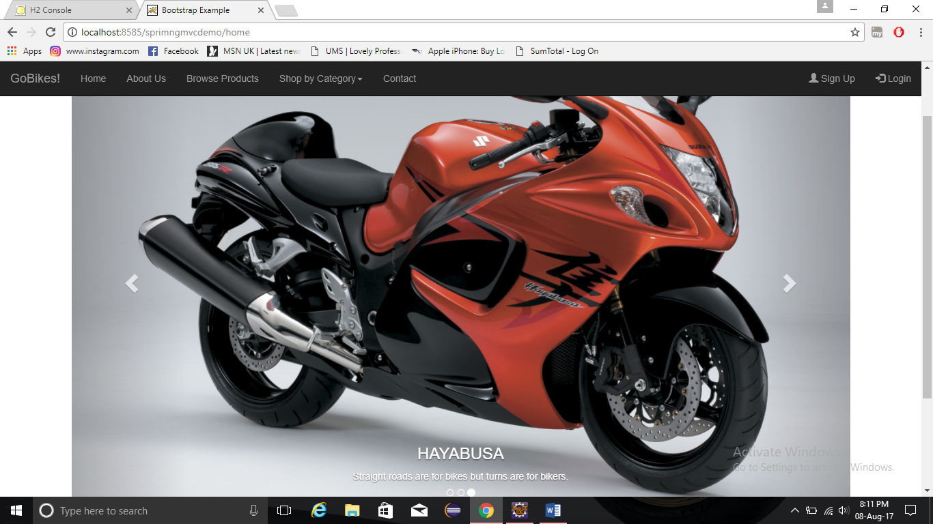

This is the home page of GoBikes! web application.

About Us Page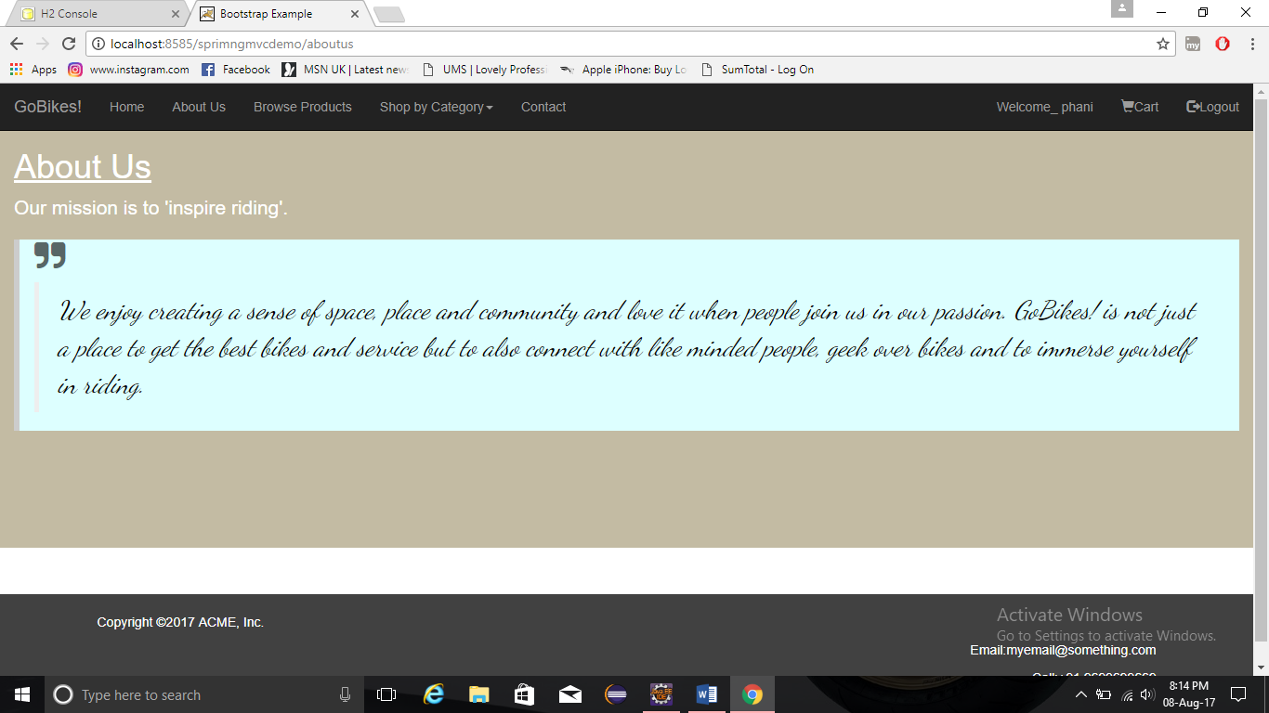

This is about us page of GoBikes!

Contact Page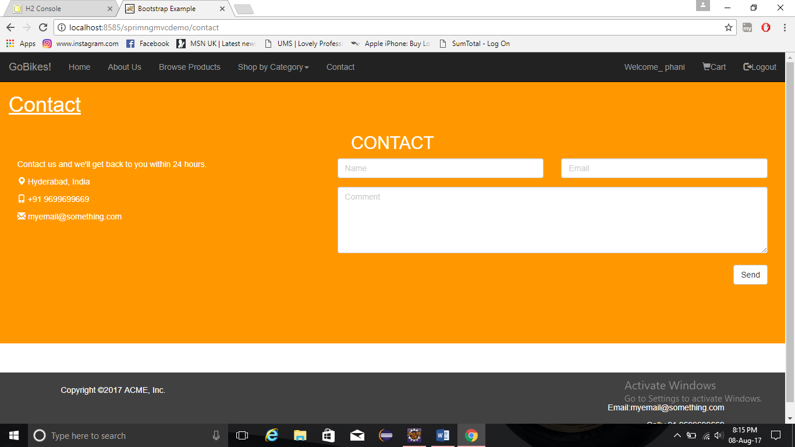

This is the contact page of Gobikes!

Sign Up Page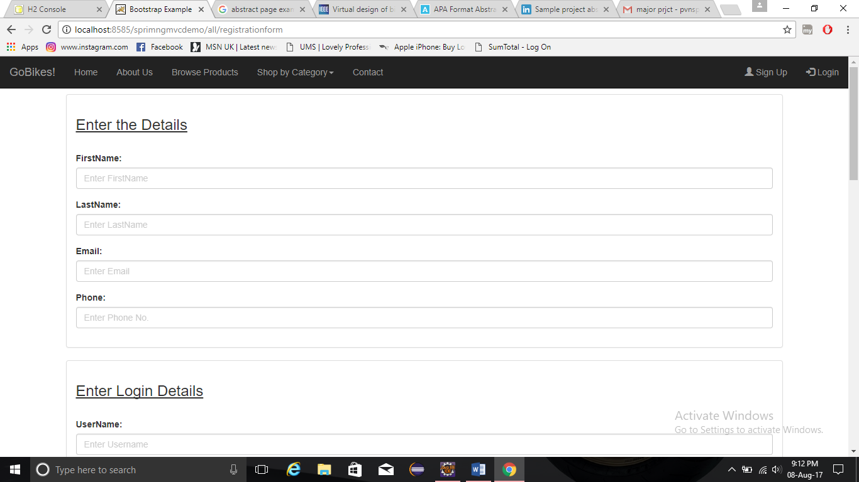

This page enables user to register with his detailed information to log into the application.

Login Page (as User)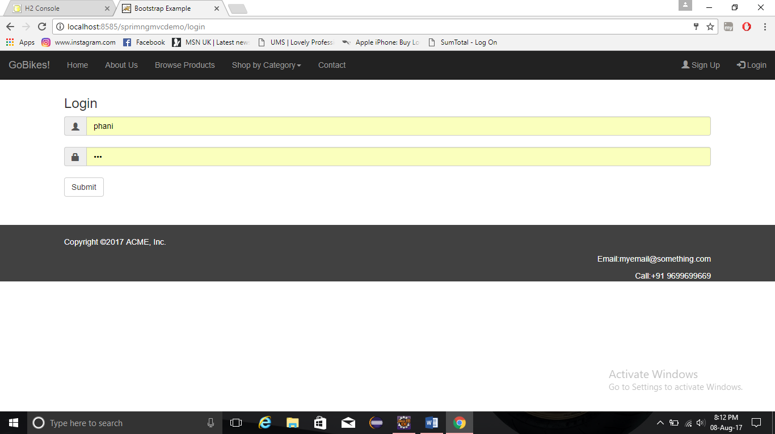

This is the login page of user where user enters into the application as customer.

Browse Products Page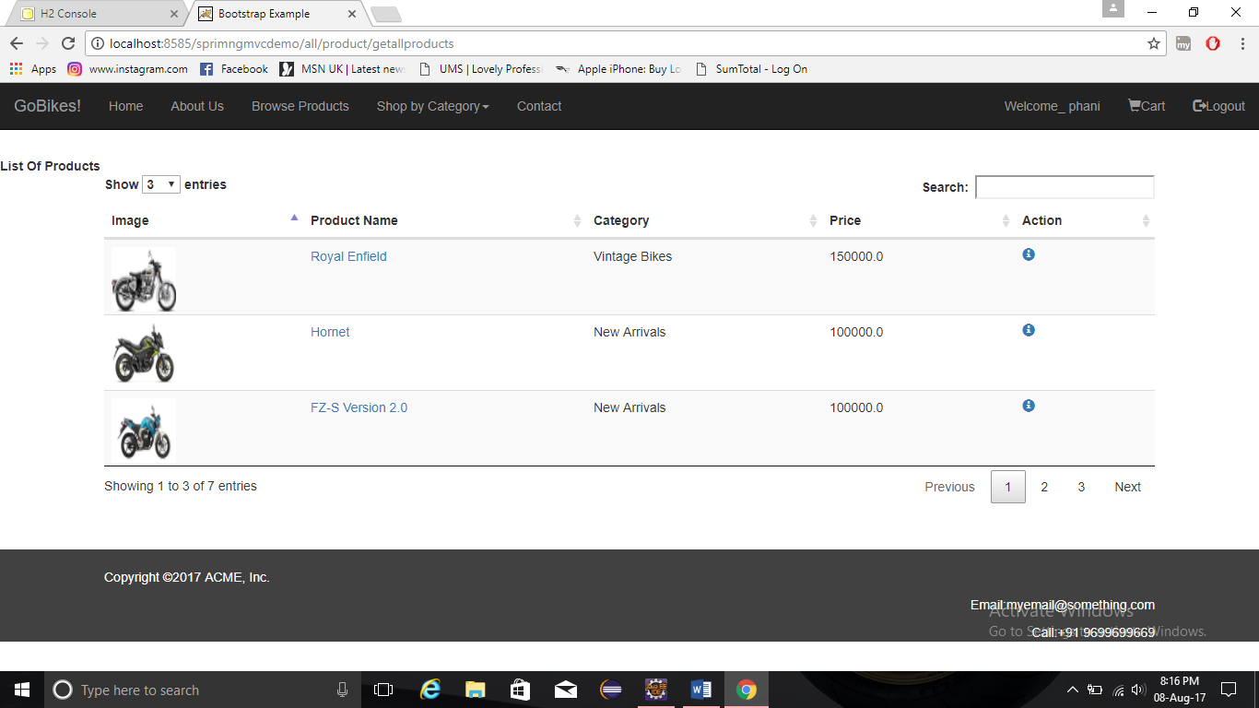

This page gives list of products available in the application for purchase.

Shop By Category Page (i.e. New Arrivals)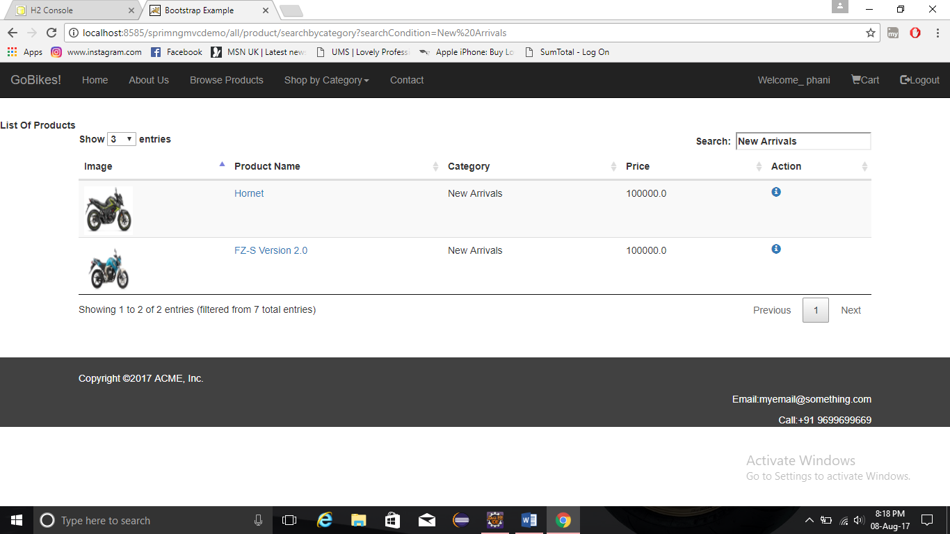

User can also shop available products based on the categories by giving an entry in search field.

Product Details Page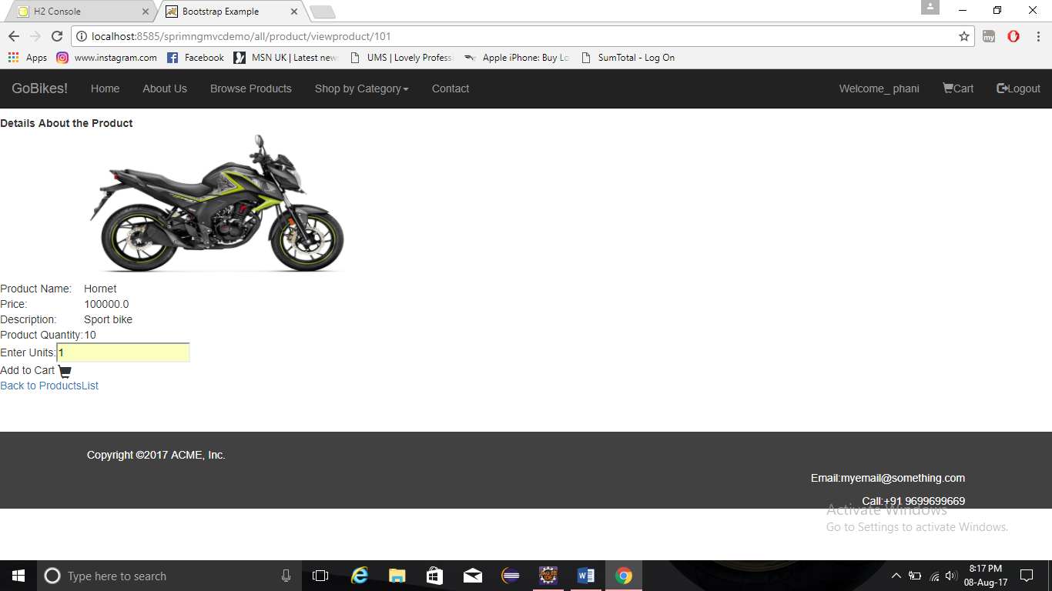

This page gives detail description of that particular product which is selected by user.

Cart Page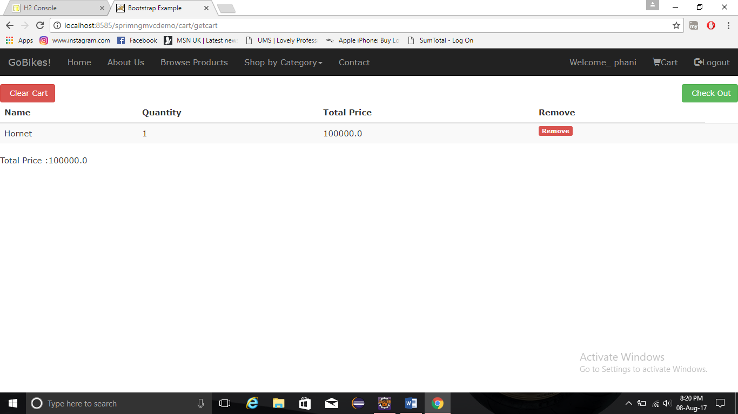

This is the page where user gets redirected after adding a product into the cart.

Checkout Page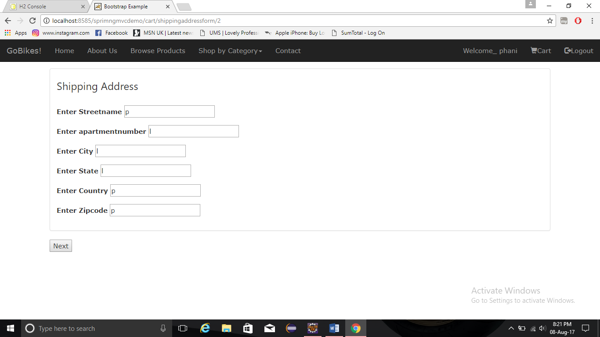

This is the checkout page where user has to enter the shipping address to purchase product which is in the cart.

Receipt Page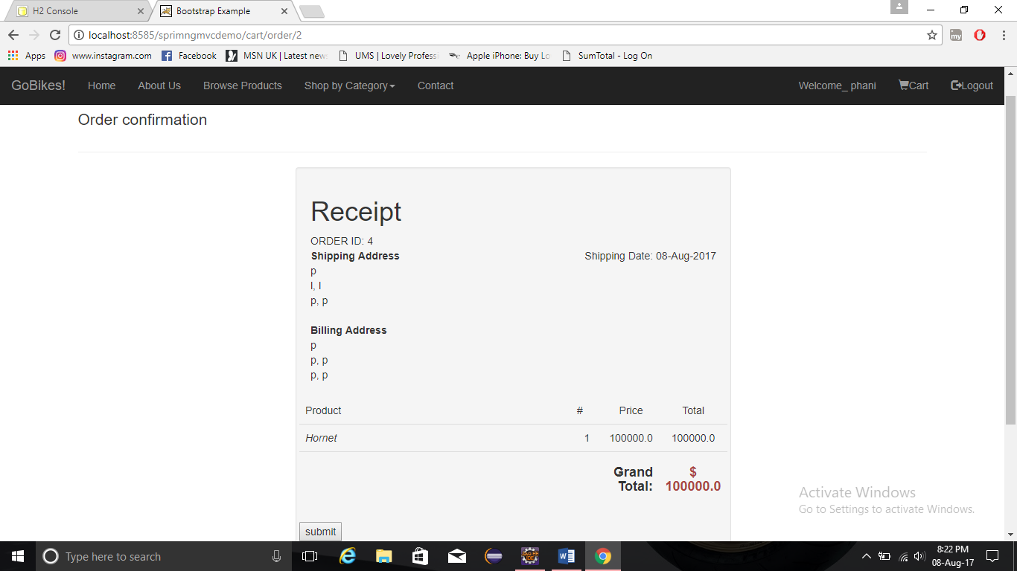

This is the receipt of purchased products.

Thankyou Page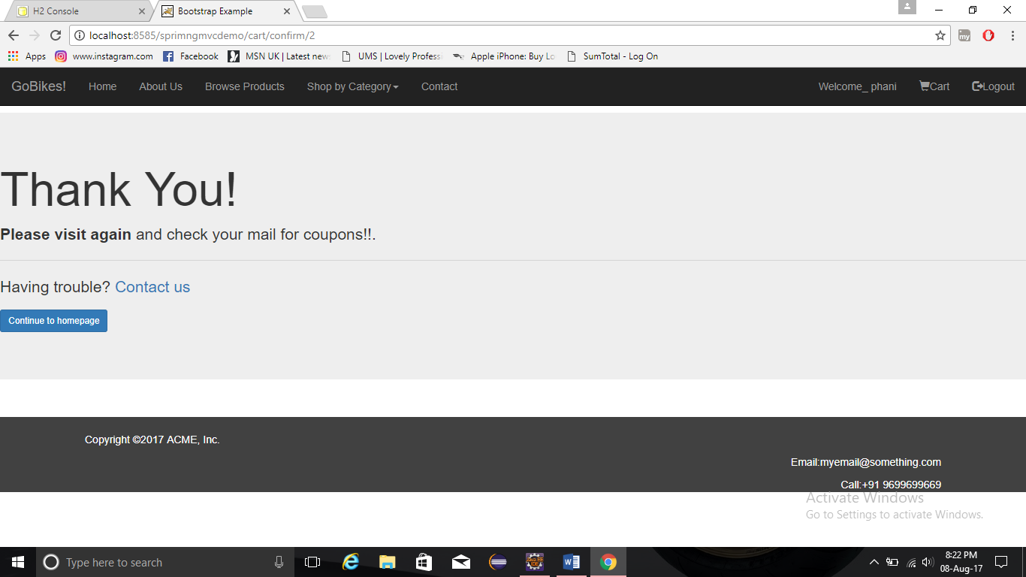

This is the last page after successfully purchasing a product by user.

Login Page (as Admin)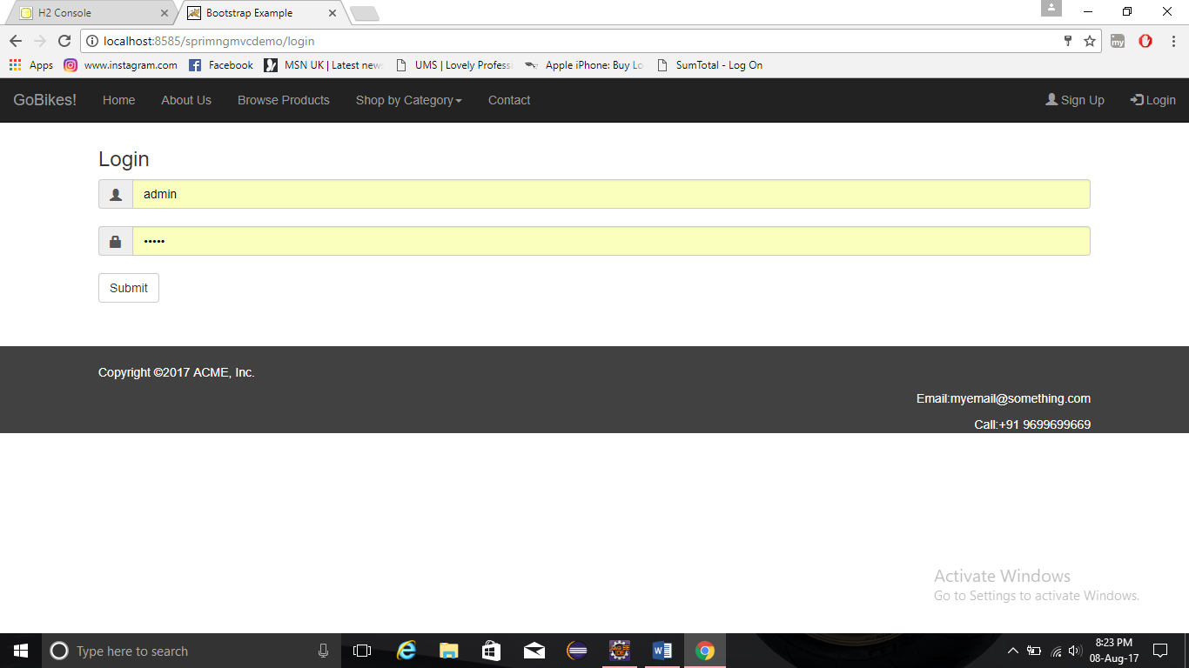

This the login page where admin is trying to log into the application.

Add Product Page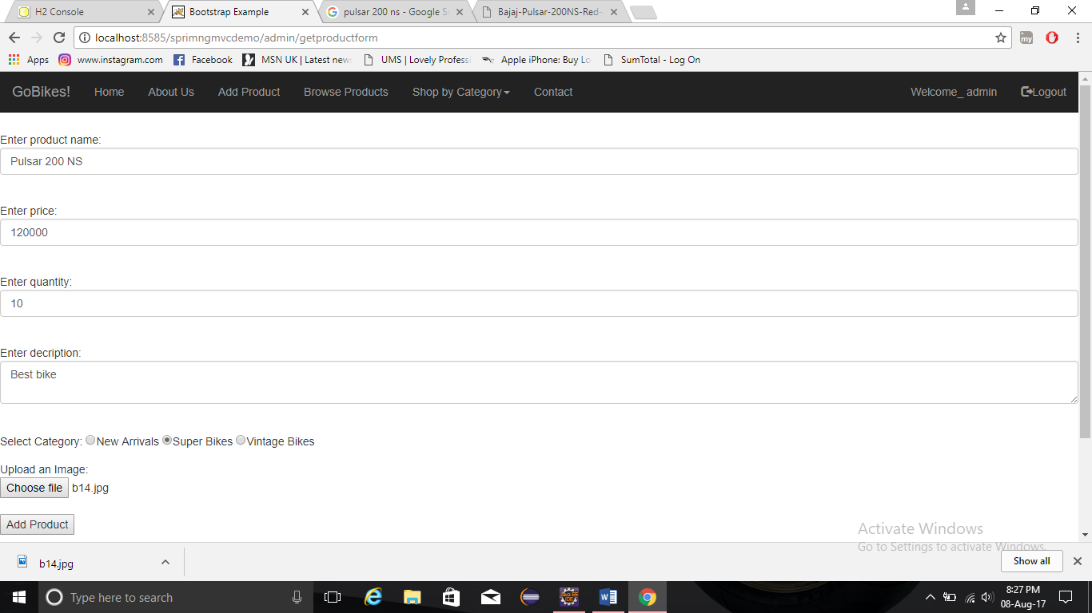

This page enables admin to add products into the application available for users.

Edit Page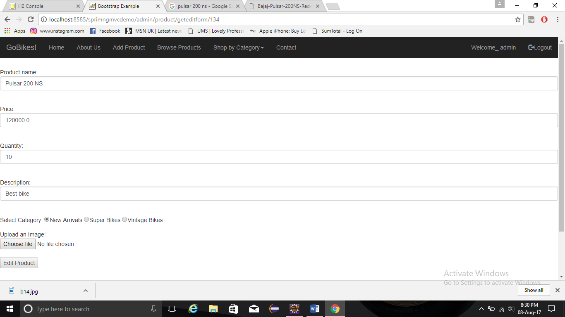

This is the page where admin can edit the already added product in the application.